**Docker**

**What is Physical Machine or Server?**

A physical machine or physical server refers to a tangible, hardware-based computing system that exists physically, as opposed to existing virtually or in the cloud. It is a standalone piece of hardware with its own physical components, such as a motherboard, central processing unit (CPU), memory (RAM), storage devices, network interfaces, and other hardware components.

**Here are some key characteristics of a physical machine or physical server:**

* **Independent Hardware:** A physical machine is a self-contained unit with its own dedicated hardware resources. It is not shared with other virtual machines or servers.
* **Operating System (OS):** Physical machines typically run a full-fledged operating system (OS) directly on the hardware. Common server operating systems include Linux distributions (e.g., Ubuntu, CentOS) or Windows Server.
* **Direct Access to Hardware Resources:** Applications and the operating system on a physical machine have direct access to the underlying hardware resources, providing optimal performance without the virtualization overhead.
* **Single Tenancy:** A physical server is single-tenancy, meaning that the entire machine is dedicated to a specific set of tasks or applications. This is in contrast to virtualization, where multiple virtual machines can run on the same physical server.
* **Deployment Data Centers or On-Premises:** Physical servers can be deployed in on-premises data centers or co-location facilities, providing organizations with control over the physical infrastructure.
* **Higher Resource Capacity:** Physical servers typically have higher resource capacity compared to individual virtual machines on the same hardware, making them suitable for resource-intensive applications.
* **Maintenance and Upgrades:** Physical servers require manual maintenance, upgrades, and replacements of hardware components. This may involve downtime for the services running on the server.

While physical machines have been the traditional form of server infrastructure, the advent of virtualization and cloud computing has introduced alternative deployment models. Virtual machines (VMs) allow multiple virtual servers to run on a single physical machine, providing greater flexibility and resource efficiency. In contrast, physical machines offer advantages in terms of raw performance, predictable resource allocation, and control over the hardware environment. The choice between physical and virtual infrastructure depends on specific use cases, performance requirements, and organizational preferences.

**What is Hypervisor and its role and responsibilities?**

A hypervisor, also known as a Virtual Machine Monitor (VMM), is a software or firmware layer that allows multiple operating systems (OS) to share a single physical hardware host. It facilitates the creation and management of virtual machines (VMs) by abstracting the underlying hardware resources and providing each VM with a virtualized environment.

The primary role of a hypervisor is to enable virtualization, allowing multiple operating systems to run concurrently on a single physical machine.

**There are Two main types of hypervisors:**

* **Type 1 Hypervisor (Bare-Metal Hypervisor):**
  + **Direct Interaction with Hardware:** A Type 1 hypervisor runs directly on the physical hardware without the need for a host operating system. It has direct access to the underlying hardware resources.

Type 1 Hypervisor

Hardware of Physical Machine

* + **Efficiency and Performance:** Since there is no intermediate host OS, Type 1 hypervisors often provide better performance and resource utilization compared to Type 2 hypervisors.
  + **Examples:**
    - VMware vSphere/ESXi
    - Microsoft Hyper-V (when installed as standalone without Windows OS)
* **Type 2 Hypervisor (Hosted Hypervisor):**
  + **Runs top of Host Operating System:** A Type 2 hypervisor runs on top of a host operating system in your physical machine. It relies on the host OS to manage hardware resources and provides virtualization capabilities to guest operating systems.

Type 2 Hypervisor

Operating System of Physical Machine

Hardware of Physical Machine

* + **Easy of Use Setup:** Type 2 hypervisors are easier to install and use, making them suitable for development and testing environments.
  + **Examples:**
    - VMware Workstation
    - Oracle VirtualBox

**Roles and Responsibilities of hypervisors:**

* **Virtualization of Hardware:** The hypervisor abstracts physical hardware resources (CPU, memory, storage, network) and presents them to VMs as virtualized resources.
* **Isolation of Virtual Machine:** Each VM operates in its own isolated environment, preventing interference and conflicts between VMs. This isolation enhances security and stability.
* **Resources Allocation and Scheduling:** The hypervisor manages the allocation of physical resources to VMs, ensuring fair distribution and efficient utilization. It also handles resource scheduling to avoid contention.
* **Virtual Machine Creation and Configuration:** The hypervisor allows the creation, configuration, and deployment of virtual machines. Users can define VM characteristics such as CPU, memory, and disk space.
* **Snapshot and Cloning:** Hypervisors often support features like snapshotting, which allows the capture and restoration of a VM's state, and cloning, which enables the rapid creation of identical VM copies.
* **Live Migration:** Some hypervisors support live migration, allowing VMs to be moved from one physical host to another without downtime. This is useful for load balancing and maintenance.
* **Security Features:** Hypervisors may include security features such as secure boot, encrypted VMs, and isolation mechanisms to enhance the overall security of virtualized environments.
* **Monitoring and Reporting:** Hypervisors provide tools and interfaces for monitoring the performance and health of virtualized environments. This includes metrics related to resource usage, VM activity, and more.

Hypervisors play a crucial role in data centers, cloud computing environments, and virtualization platforms by enabling the efficient and flexible use of hardware resources. They facilitate the creation and management of VMs, allowing organizations to run multiple operating systems and applications on a single physical server.

**What is Virtualization?**

Virtualization is a technology that allows multiple virtual instances of operating systems (OS), applications, or resources to run on a single physical machine. The primary goal of virtualization is to maximize resource utilization, increase flexibility, and improve efficiency in computing environments. Virtualization is basically creating a lot of virtual machines or virtual servers top of physical machines.

**Key components and concepts of virtualization include:**

* **Hypervisor (Virtual Machine Monitor - VMM):** The hypervisor is a software or firmware layer that enables the creation and management of virtual machines (VMs) on a physical host. It abstracts and virtualizes the underlying hardware, allowing multiple VMs to coexist on the same physical machine.
* **Virtual Machines (VMs):** VMs are instances of virtualized operating systems and applications that run on a host machine. Each VM operates as if it were a standalone physical machine, with its own virtualized hardware resources, including CPU, memory, storage, and network interfaces.
* **Host Machine:** The physical hardware that runs the hypervisor and hosts the virtual machines. It can be a server, desktop, or other computing device.
* **Resource Pooling:** Virtualization allows the pooling of physical resources such as CPU, memory, and storage. These resources are then dynamically allocated to VMs based on demand.
* **Isolation:** VMs are isolated from each other, providing security and preventing interference. Failures or issues in one VM typically do not affect others.
* **Snapshot and Cloning:** Virtualization platforms often support features like snapshotting, which captures the current state of a VM for backup or recovery, and cloning, which allows the rapid creation of identical VM copies.
* **Live Migration:** Some virtualization systems support live migration, enabling the movement of VMs from one physical host to another without disrupting services. This is useful for load balancing and maintenance.
* **Flexible Scaling:** Virtualization provides the ability to scale resources up or down as needed. VMs can be easily provisioned or decommissioned, allowing for efficient resource allocation.

**Types of virtualization include:**

* **Server Virtualization:** Multiple virtual servers run on a single physical server, enabling better resource utilization and management.
* **Desktop Virtualization:** Virtual desktops run on a central server, allowing users to access their desktop environments from different devices.
* **Network Virtualization:** Virtualization of network resources, enabling the creation of virtual networks and network services.
* **Storage Virtualization:** Abstraction of physical storage resources to create a virtualized storage pool that can be dynamically allocated.

Virtualization is a fundamental technology in modern computing, enabling the consolidation of workloads, improved hardware utilization, and increased agility in managing IT infrastructure. It plays a crucial role in data centers, cloud computing, and various other computing environments.

**What is Virtual Machine (VMs)?**

A Virtual Machine (VM) is a software emulation of a physical computer that runs an operating system and applications. It allows multiple instances of operating systems to coexist and run on a single physical machine. Each virtual machine operates independently and is isolated from the others, providing a way to consolidate and efficiently utilize hardware resources.

VM-4

(OS)

VM-3

(OS)

VM-2

(OS)

VM-1

(OS)

Type 2 Hypervisor

Hardware of Physical Machine

Operating System of Physical Machine

**Importance of Virtual Machines (VMs):**

* **Resource Utilization:** VMs allow for better utilization of physical hardware by running multiple operating systems on a single server. This leads to improved resource efficiency and reduced hardware costs.
* **Isolation:** VMs provide isolation between different operating systems and applications. Failures or issues in one VM do not impact others, enhancing security and stability. The VMs are tightly separated, because they have individual operating system.
* **Flexibility and Scalability:** VMs can be easily provisioned or decommissioned, providing flexibility in scaling resources based on demand. This agility is crucial in dynamic computing environments.
* **Consolidation:** Virtualization enables the consolidation of workloads, allowing organizations to run multiple applications on a single physical server without interference.
* **Snapshot and Cloning:** VMs support snapshotting, allowing the capture of a VM's current state for backup or recovery purposes. Cloning allows the rapid creation of identical VM copies.
* **Testing and Development:** VMs are widely used in testing and development environments, providing developers with isolated environments to test software or deploy applications.
* **Legacy Application Support:** VMs can run older or legacy applications that might not be compatible with the host operating system or hardware.

**Roles and Responsibilities of Virtual Machines (VMs):**

* **Execution of Operating System:** VMs run complete operating systems just like physical machines. They execute applications and services within their own virtualized environment.
* **Resources Allocation and Managements:** VMs receive virtualized resources from the hypervisor, including CPU, memory, storage, and network interfaces. The hypervisor manages the allocation of these resources based on demand.
* **Isolation and Security:** VMs provide isolation between different instances, ensuring that each VM operates independently. This isolation enhances security and prevents interference between VMs.
* **Application Hosting:** VMs host applications and services, allowing organizations to deploy multiple applications on a single physical server without conflicts.
* **Dynamic Scaling:** VMs support dynamic scaling, allowing for the adjustment of allocated resources to meet changing workloads.
* **Snapshotting and Scaling:** VMs support features such as snapshotting and cloning, providing mechanisms for backup, recovery, and rapid deployment.
* **Compatibility and Probability:** VMs encapsulate an entire operating system and its dependencies, making them portable across different environments. This enhances compatibility and simplifies deployment.
* **Integration and Cloud Services:** VMs are integral to cloud computing services, where they provide the foundation for deploying and managing virtualized resources.

Virtual machines play a critical role in modern IT infrastructure, offering flexibility, efficiency, and scalability. They have become a cornerstone technology in data centers, cloud computing environments, and various enterprise computing scenarios.

**Drawback of Virtual Machine (VM)?**

While virtual machines (VMs) offer numerous benefits, they also come with some drawbacks. It's important to consider these limitations when deciding whether to use virtualization in a specific context.

**Here are some drawbacks of virtual machines:**

* **Resource Overhead:** Virtualization introduces some level of resource overhead. Each VM includes its own operating system (OS) and requires additional resources for virtualization, leading to higher memory and CPU usage compared to running applications directly on the host machine.
* **Performance:** VMs may experience a performance penalty due to the virtualization layer. While this overhead has diminished with advancements in virtualization technologies, certain workloads, especially those with high-performance requirements, may be better suited for running directly on physical hardware.
* **Complexity:** Managing virtualized environments can be complex. Configuring and maintaining VMs, dealing with virtual networks, and managing storage in a virtualized environment can be more intricate than managing physical machines.
* **Hypervisor Vulnerabilities:** The hypervisor, which manages and controls the VMs, introduces a potential point of vulnerability. A security breach at the hypervisor level could impact all VMs running on the host.
* **License Cost:** Some virtualization platforms and management tools may involve licensing costs. While there are open-source solutions available, enterprise-grade virtualization solutions may come with associated expenses.
* **Limited Hardware Access:** VMs have limited access to physical hardware components. Certain hardware-specific features may not be fully accessible to VMs, particularly if the hypervisor abstracts or restricts access to certain functionalities.
* **Network Complexity:** Managing virtual networks and ensuring proper connectivity between VMs and the external network can be challenging. Misconfigurations or complexities in network setups may lead to communication issues.
* **Storage Challenges:** Virtualized environments often rely on shared storage, which can introduce challenges in terms of storage performance, scalability, and potential points of failure.
* **Backup and Recovery Complexity:** VM backup and recovery processes can be more complex than those for physical machines. Coordinating the backup and recovery of multiple VMs while ensuring consistency can pose challenges.
* **Limited CPU Performance:** Virtualizing graphics processing units (GPUs) for high-performance graphical applications can be challenging. While some advancements have been made in this area, certain workloads may still be better suited for direct GPU access on physical machines.

Despite these drawbacks, it's important to note that many organizations successfully use virtualization to achieve cost savings, improved resource utilization, and flexibility in managing IT infrastructure. The choice between virtual machines and physical machines depends on specific use cases, performance requirements, and organizational priorities. Additionally, advancements in technology continue to address some of the traditional limitations associated with virtualization.

**What is container?**

**A container is a lightweight, portable, and executable software package** that includes everything needed to run a piece of software, including the code, runtime, libraries, system tools, and snapshot of OS. Containers provide a consistent and isolated environment for applications to run, ensuring that they behave the same way across different computing environments.

**Key characteristics of containers include:**

* **Isolation:** Containers encapsulate applications and their dependencies, ensuring isolation from the underlying host system and other containers. This isolation helps prevent conflicts and ensures that the application runs consistently.
* **Portability:** Containers are highly portable, allowing applications to run consistently across different environments, such as development machines, testing servers, and production servers. This portability is facilitated by containerization technologies like Docker.
* **Lightweight:** Containers are lightweight compared to virtual machines. **They share the host operating system's kernel and only include the necessary components for the application**, reducing resource overhead.
* **Efficiency:** Containers can be started and stopped quickly, making them highly efficient for deployment and scaling. They are well-suited for microservices architectures and container orchestration platforms.
* **Immutable Infrastructure:** Containers are often treated as immutable infrastructure. Once a container image is built, it remains unchanged during its lifecycle. Updates are applied by creating a new version of the container image.
* **Dependency Managements:** Containers encapsulate dependencies, making it easier to manage and version software dependencies. This helps avoid conflicts and ensures that the application runs consistently across different environments.
* **Orchestration:** Container orchestration tools, such as Kubernetes and Docker Swarm, help automate the deployment, scaling, and management of containerized applications in a cluster of machines.

Popular containerization technologies include Docker, which has become a de facto standard for containerization, and container orchestration platforms like Kubernetes, which facilitate the deployment and management of containerized applications at scale.

**Types of Container:**

* **Component A:** Where we use Physical Machine or Physical Server and top of that use containers.

Hardware of Physical Machine

Operating System of Physical Machine

Type 2 Hypervisor/ Docker

Container-4

Container-3

Container-2

Container-1

* **Component B:** Where we use Virtual Machine (VM, e.g. EC2 instance) and top of that use containers.

Virtual Machine (EC2 Instance)

Operating System of Virtual Machine

Type 2 Hypervisor/ Docker

Container-4

Container-3

Container-2

Container-1

**Components of Containers:**

* **Container Image:** A container image is a lightweight, standalone, and executable software package that includes the application code, runtime, libraries, and other dependencies needed to run the application.
* **Container Runtime:** The container runtime is responsible for executing the container images. Docker is a commonly used container runtime, but there are others, such as container and rkt.
* **Container Orchestrator:** Container orchestrators automate the deployment, scaling, and management of containers. Kubernetes is a widely adopted container orchestration platform.

**Advantages of Containers:**

* **Consistency:** Containers ensure consistent application behavior across different environments.
* **Efficiency:** Containers are lightweight and resource-efficient, allowing for faster deployment and scaling.
* **Isolation:** Containers provide isolation between applications, reducing conflicts and dependencies.
* **Portability:** Containers can be easily moved between different environments, promoting a "write once, run anywhere" approach.
* **Rapid Deployment:** Containers can be started and stopped quickly, facilitating rapid application deployment and updates.

Containers have revolutionized the way applications are developed, deployed, and managed, particularly in modern cloud-native and microservices architectures. They offer a flexible and scalable approach to software delivery, supporting the demands of today's dynamic computing environments.

**Why containers are light weighted.**

Containers are considered lightweight primarily because **they share the host operating system's kernel** **and utilize a container runtime to package and execute applications**.

Containers are lightweight because they use a technology called containerization, which allows them to share the host operating system's kernel and libraries, while still providing isolation for the application and its dependencies. This results in a smaller footprint compared to traditional virtual machines, as the containers do not need to include a full operating system. Additionally, Docker containers are designed to be minimal, only including what is necessary for the application to run, further reducing their size.

**Let's try to understand this with an example:**

Below is the screenshot of official ubuntu base image which you can use for your container. It's just ~ 22 MB, isn't it very small? on a contrary if you look at official ubuntu VM image it will be close to ~ 2.3 GB. So, the container base image is almost 100 times less than VM image.

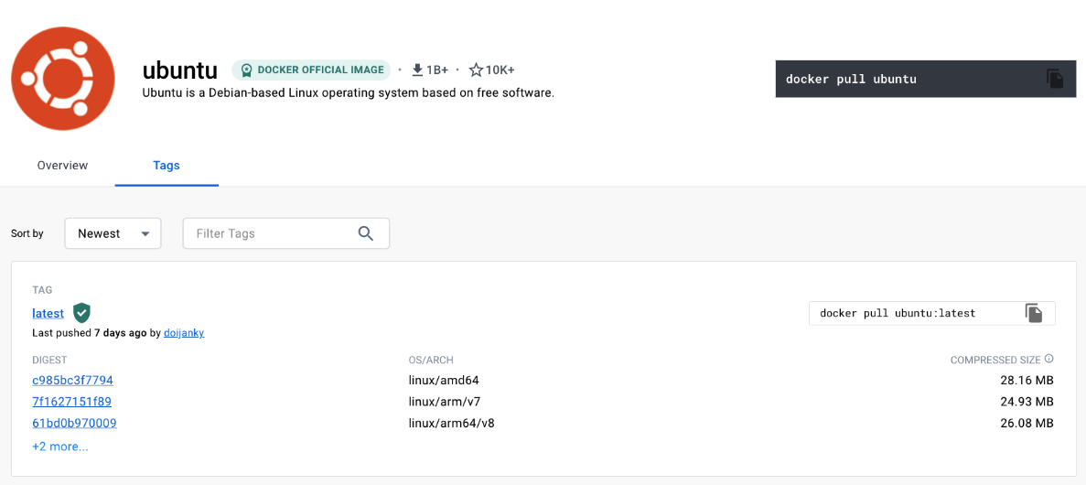

**What is base image in Container?**

In containerization, a base image is the foundational layer of a container image. **It serves as the starting point for building a containerized application**. **A base image typically contains a minimal operating system environment with essential libraries and services required to run an application**. It provides the basic runtime environment and dependencies that the application needs to execute.

**Key characteristics of a base image include:**

* **Minimal Operating System:** A base image usually includes a **minimal** or slimmed-down **version of an operating system**. It may only include the essential components necessary for running applications.
* **Common Runtimes and Libraries:** Base images include common runtime environments, such as those for a specific programming language or framework, along with necessary libraries and dependencies. This helps ensure compatibility with the application being containerized.
* **Immutable:** Base images are typically considered **immutable**, meaning that their contents do not change during the container's runtime. This immutability principle aligns with the idea of immutable infrastructure, where changes are made by creating new versions rather than modifying existing instances.
* **Layered File System:** Container images are often built using a layered file system. Each layer represents a specific set of changes or additions to the file system. The base image forms the initial layer, and subsequent layers are added to customize the image according to the application's requirements.
* **Tagging and Versioning:** Base images are often tagged and versioned to specify a particular release or version of the image. This helps ensure consistency and reproducibility in the containerized environment.
* **Community and Official Images:** Many base images are available as pre-built and publicly accessible images in container registries. These can be community-contributed or provided by the maintainers of specific software projects. Official images from software vendors are often considered reliable and secure.
* **Purpose-Specific:** Base images can be designed for specific purposes, such as running a web server, executing a database server, or supporting a particular programming language. Purpose-specific base images help streamline the containerization process for specific use cases.

When creating a Dockerfile or another containerization configuration file, developers typically start with a base image and then add customizations, dependencies, and the application code in subsequent layers. This layering approach helps optimize resource utilization and facilitates the sharing of common layers among multiple images.

**Why we move to container instead of VM?**

Moving to containers instead of virtual machines (VMs) offers several advantages in modern application development and deployment.

**Here are some key reasons why organizations often choose containers over VMs:**

* **Lightweight and Efficient Resource Utilization:** Containers share the host operating system's kernel, making them more lightweight than VMs. They have a smaller footprint, start quickly, and consume fewer resources. This efficiency allows for better resource utilization, especially in environments with large-scale deployments.
* **Rapid Deployment and Scaling:** Containers can be started and stopped quickly, enabling rapid deployment and scaling. They are well-suited for dynamic workloads and microservices architectures where applications need to scale up or down based on demand.
* **Consistency Across Environments:** Containers encapsulate an application and its dependencies, ensuring consistent behavior across different environments, from development to testing and production. This "write once, run anywhere" approach simplifies application deployment and reduces the likelihood of issues caused by environmental differences.
* **Portability:** Containers are highly portable, allowing applications to run consistently across various environments and infrastructure platforms. This portability is beneficial in hybrid and multi-cloud environments, where applications need to move seamlessly between on-premises data centers and public clouds.
* **Microservices Architecture:** Containers align well with microservices architecture, where applications are composed of small, independently deployable services. Containers facilitate the development, deployment, and scaling of individual microservices, promoting agility and modularity in application design.
* **Resource Efficiency:** Containers share the host OS kernel, minimizing the overhead associated with running multiple instances of an operating system. This results in efficient use of resources, especially in scenarios where many small application components need to run concurrently.
* **Faster Boot Times:** Containers can be launched and initialized quickly, leading to faster boot times compared to VMs. This speed is advantageous in scenarios where applications need to scale rapidly or respond to dynamic changes in demand.
* **Immutable Infrastructure:** Containers follow the principle of immutable infrastructure, where changes are made by creating new container images rather than modifying existing instances. This approach simplifies version control, rollback procedures, and ensures consistency in deployment.
* **DevOps and CI/CD Integration:** Containers seamlessly integrate with DevOps practices and continuous integration/continuous deployment (CI/CD) pipelines. The encapsulation of dependencies within containers enhances collaboration between development and operations teams and facilitates automated testing and deployment workflows.
* **Container Orchestration:** Container orchestration platforms, such as Kubernetes, provide robust tools for managing and scaling containerized applications. These platforms automate tasks like load balancing, scaling, and service discovery, making it easier to manage large-scale container deployments.

While containers offer numerous advantages, it's essential to note that the choice between containers and VMs depends on specific use cases, requirements, and the overall architecture of the application. In some scenarios, a combination of both containers and VMs may be the optimal solution.

**What is Docker?**

Docker is a platform for developing, shipping, and running applications in containers. It provides a set of tools and a platform to simplify the process of creating, deploying, and managing applications within lightweight, portable, and self-sufficient containers. [**GitHub Link**](https://github.com/iam-veeramalla/Docker-Zero-to-Hero)

Virtual Machine (EC2 Instance)

Operating System of Virtual Machine or Host

Docker

Container-4

Container-3

Container-2

Container-1

App-4

App-3

App-2

App-1

**Key components and concepts associated with Docker include:**

* **Docker Engine:** The Docker Engine is the core runtime environment that executes and manages containers. It includes a server, a REST API for interacting with the engine, and a **command-line interface** (**CLI**) for users to interact with Docker.
* **Docker Container:** A Docker container is a lightweight, standalone, and executable software package that includes everything needed to run a piece of software, including the code, runtime, libraries, and system tools. Containers are isolated from each other and share the host operating system's kernel.
* **Docker Image: A Docker image is a read-only template that contains the instructions for creating a container**. It includes the application code, runtime, libraries, and other dependencies. Images are used to build containers.
* **Dockerfile:** A Dockerfile is a text file that contains instructions for building a Docker image. It specifies the base image, sets up the environment, adds files, and defines commands to run when the container starts. Dockerfiles allow users to create reproducible and version-controlled builds.
* **Docker Registry:** Docker images can be stored and shared in registries. A Docker registry is a repository for storing and managing Docker images. The default public registry is Docker Hub, and organizations can set up private registries for internal use.
* **Docker Compose:** Docker Compose is a tool for defining and running multi-container Docker applications. It allows users to specify a multi-container application setup in a YAML file, defining services, networks, and volumes.
* **Docker Swarm:** Docker Swarm is Docker's native clustering and orchestration solution. It allows users to create and manage a swarm of Docker nodes, turning them into a single, virtual Docker Engine. Swarm enables the deployment and scaling of services across a cluster of machines.
* **Docker CLI:** The Docker command-line interface (CLI) is used to interact with Docker. Users can use the CLI to build, run, stop, and manage containers, as well as to work with images, networks, and volumes.

Docker has become a widely adopted technology in the software development and DevOps communities. It simplifies the deployment and management of applications by encapsulating them in containers, ensuring consistency across different environments. Docker's popularity is attributed to its ease of use, portability, and the ability to facilitate modern application development practices, such as microservices architecture and continuous integration/continuous deployment (CI/CD).

**Architecture of Docker.**

The architecture of Docker is designed to enable the creation, distribution, and execution of containerized applications. Docker uses a client-server architecture, where the Docker client communicates with the Docker daemon, and the daemon manages the containers on the host system.

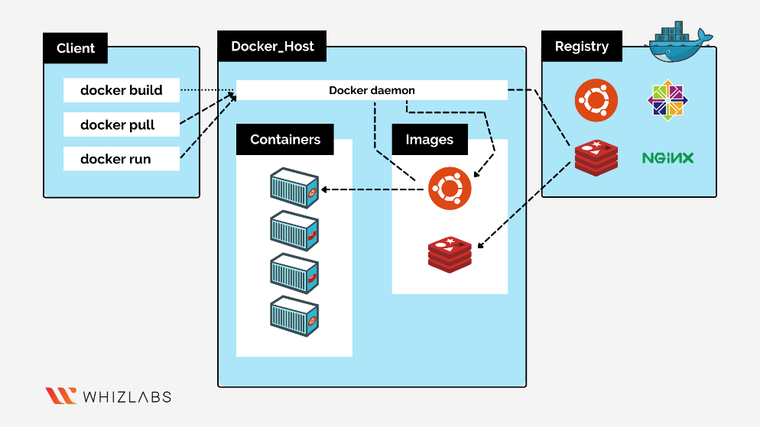

**The key components of Docker architecture include:**

* **Docker Daemon:** The Docker daemon, also known as **dockerd,** is a background process running on the host system. **It is responsible for building, running, and managing Docker containers**. The daemon listens for Docker API requests and manages container-related tasks such as creating, stopping, and removing containers.
* **Docker Client:** The Docker client is the command-line interface (CLI) tool that allows users to interact with the Docker daemon. Users issue commands using the Docker CLI to build, run, and manage containers. The Docker client communicates with the Docker daemon through the Docker API.
* **Docker Registry:** Docker images can be stored and shared in registries. A Docker registry is a repository for storing and managing Docker images. The default public registry is Docker Hub, and organizations can set up private registries for internal use.
* **Docker Image:** A Docker image is a read-only template that contains the instructions for creating a container. It includes the application code, runtime, libraries, and other dependencies. Images are used to build containers.
* **Docker Container:** A Docker container is a lightweight, standalone, and executable software package that includes everything needed to run a piece of software, including the code, runtime, libraries, and system tools. Containers are isolated from each other and share the host operating system's kernel.
* **Docker Compose:** Docker Compose is a tool for defining and running multi-container Docker applications. It allows users to specify a multi-container application setup in a YAML file, defining services, networks, and volumes.
* **Docker Swarm:** Docker Swarm is Docker's native clustering and orchestration solution. It allows users to create and manage a swarm of Docker nodes, turning them into a single, virtual Docker Engine. Swarm enables the deployment and scaling of services across a cluster of machines.
* **Docker API:** The Docker API is a RESTful API that allows external tools and applications to communicate with the Docker daemon. The Docker client interacts with the Docker daemon through this API. Automation tools, container orchestration platforms, and other integrations use the Docker API to manage containers and services.
* **Docker Network: Docker provides networking capabilities to enable communication between containers and with external networks**. Containers can be connected to different network modes, including bridge, host, overlay, and custom networks. Docker networks facilitate secure communication between containers.

**Docker Architecture Flow:**

* **User Interaction:** The user interacts with the Docker client using the Docker CLI or other tools.
* **Docker Client:** The Docker client sends commands to the Docker daemon using the Docker API.
* **Docker Daemon:** The Docker daemon receives commands from the client and executes them. It manages container lifecycle, networking, storage, and other tasks. The daemon communicates with the host OS's kernel to create and manage containers.
* **Docker Registry:** Docker daemon pulls images from a Docker registry when creating containers. Images can be stored locally or fetched from public or private registries.
* **Docker Image:** Docker images are the building blocks for containers. They are created from a set of instructions in a Dockerfile and can be versioned and tagged for different releases.
* **Docker Container:** Docker containers are instantiated from Docker images. Each container runs in an isolated environment, sharing the host OS's kernel but having its own user space.
* **Docker Compose and Swarm:** Docker Compose and Docker Swarm are used for orchestrating and managing multi-container applications. They provide tools for defining, deploying, and scaling services in a cluster.

Understanding the Docker architecture is crucial for effectively working with Docker, managing containers, and integrating Docker into larger systems and workflows. It provides a foundation for building, deploying, and managing containerized applications at scale.

**What is Docker Lifecycle:**

We can use the above Image as reference to understand the lifecycle of Docker.

There are three important things,

1. **docker build** **->** builds docker images from Dockerfile
2. **docker run** **->** runs container from docker images
3. **docker push ->** push the container image to public/private registries to share the docker images.

The Docker lifecycle refers to the various stages and processes that a Docker container goes through from creation to execution and eventual termination. Understanding the Docker lifecycle helps users manage and interact with containers effectively.

**Here are the key stages in the Docker container lifecycle:**

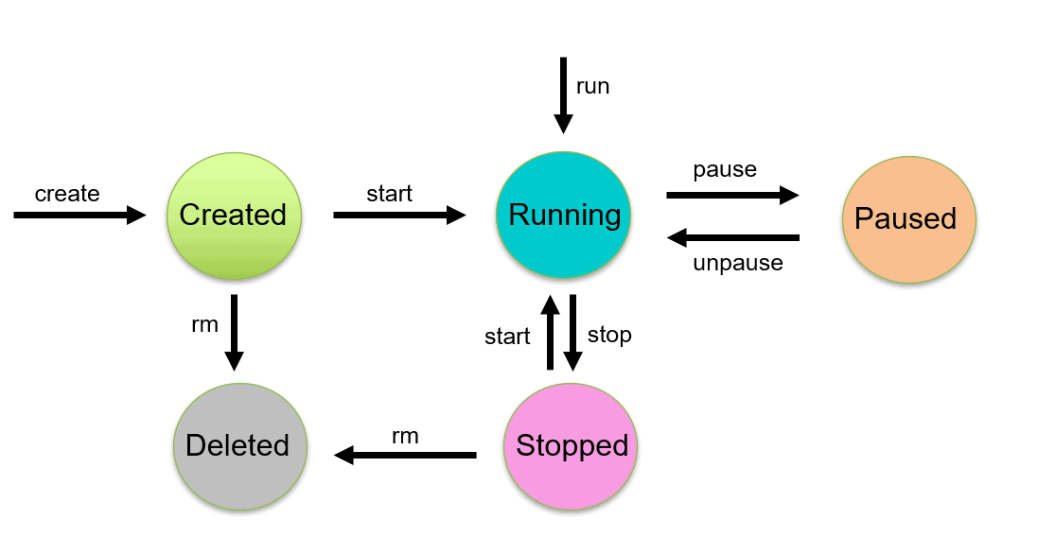

* **Image Creation:** The lifecycle begins with the creation of a Docker image. An image is a lightweight, standalone, and executable package that includes the application code, runtime, libraries, and other dependencies. Images are defined using Dockerfiles and can be built using the **docker build** command.
* **Image Registry:** Once an image is created, it can be stored in a Docker image registry. Docker Hub is a popular public registry, and organizations can set up private registries for internal use. Images in a registry can be versioned and shared with others.
* **Containerization:** To run an application, an instance of a Docker container is created from an image. Containers are created using the **docker run** command, specifying the image to use. During containerization, the image is instantiated as a running container, and it is isolated from the host system and other containers.
* **Running Container:** The container is in the "running" state when it is actively executing the commands specified in the Docker image. The application within the container is operational, and the container is isolated from the host and other containers.
* **Interacting with Containers:** Users can interact with running containers through the Docker CLI. Common operations include executing commands within a container **docker exec**, viewing container logs **docker logs**, inspecting container metadata **docker inspect**, and more.
* **Modifying Containers (Optional):** While containers are typically designed to be immutable, users may need to make changes to a running container in some scenarios. This can be done using the **docker exec** command to access the container's shell and make modifications. However, any changes made to a running container are lost when the container stops.
* **Stopping Containers:** Containers can be stopped using the **docker stop** command. This initiates a graceful shutdown of the processes within the container. The container moves from the "running" state to the "exited" state.
* **Container Restart (Optional):** Containers can be configured to automatically restart when they exit. This is useful for ensuring high availability of services. The **docker run** command can include the **--restart** flag to specify the restart policy.
* **Container Removal:** Once a container is no longer needed, it can be removed using the **docker rm** command. This removes the container instance, but it does not delete the underlying Docker image. The image remains available for creating new containers.
* **Image Updated and Versioning (Optional):** If updates or changes are made to an application, a new version of the Docker image can be created with a unique tag or version. This allows for versioned releases and ensures reproducibility of deployments.

Understanding and effectively managing the Docker lifecycle is essential for working with containerized applications. Automation tools, container orchestration platforms (e.g., Kubernetes), and continuous integration/continuous deployment (CI/CD) pipelines often play a role in streamlining and automating various stages of the Docker container lifecycle.

**What is Docker Engine? What it’s role and responsibilities? What are the pros and cons.**

**Docker Engine is the core runtime component of Docker, responsible for creating, managing, and running Docker containers**. It is a lightweight and portable containerization runtime that enables the packaging and execution of applications in isolated environments known as containers. The Docker Engine consists of several components, including a server, a REST API, and a command-line interface (CLI). It plays a central role in the Docker ecosystem, providing the foundation for containerized application development and deployment.

**Roles and Responsibilities of Docker Engine:**

* **Container Runtime:** The Docker Engine serves as the container runtime, responsible for executing and managing containers on a host system. It interacts with the host operating system's kernel to provide isolated environments for containers.
* **Image Management:** Docker Engine manages Docker images, which are templates for creating containers. It can pull images from registries, build images from Dockerfiles, and store images locally on the host system.
* **Networking:** Docker Engine handles networking for containers, creating isolated network namespaces for each container. It allows containers to communicate with each other or with external networks, while ensuring network isolation and security.
* **Storage:** Docker Engine manages storage for containers, including the creation and management of data volumes. It enables the persistence of data by allowing containers to write data to volumes that exist independently of the container lifecycle.
* **Security:** Docker Engine implements security features to isolate containers and control their access to system resources. It utilizes namespaces, control groups (cgroups), and other Linux kernel features to provide process and resource isolation.
* **REST API:** Docker Engine exposes a REST API that allows users to interact with the engine programmatically. This API is used by Docker CLI, Docker Compose, and other tools to communicate with the Docker Engine.
* **Command-Line Interface (CLI):** Docker Engine provides a command-line interface (CLI) that allows users to interact with the engine using commands. The CLI is a user-friendly way to perform various Docker-related tasks, such as building images, running containers, and managing Docker resources.

**Pros of Docker Engine:**

* **Probability:** Docker containers are highly portable, allowing applications to run consistently across different environments. This portability is valuable in various scenarios, including development, testing, and production.
* **Efficiency:** Docker containers are lightweight and share the host OS's kernel, leading to efficient resource utilization. Containers can start quickly and have lower overhead compared to virtual machines.
* **Isolation:** Docker Engine provides process and resource isolation, ensuring that containers are isolated from each other and from the host system. This enhances security and stability.
* **Microservices Architecture:** Docker is well-suited for microservices architecture, where applications are decomposed into smaller, independently deployable services. It facilitates the development, deployment, and scaling of microservices.
* **DevOps Integration:** Docker integrates well with DevOps practices, supporting continuous integration, continuous deployment (CI/CD), and automation. It streamlines the development and deployment pipeline.
* **Community and Ecosystem:** Docker has a large and active community, and there is a rich ecosystem of tools and resources built around Docker, including orchestration solutions like Kubernetes and Docker Swarm.

**Cons of Docker Engine:**

* **Security Concerns:** While Docker provides isolation, improper configuration or security vulnerabilities in containerized applications or the Docker Engine itself can pose security risks. Users need to follow best practices for securing container environments.
* **Learning Curve:** For users new to containerization, there may be a learning curve associated with understanding Docker concepts, Dockerfiles, and the Docker CLI. However, Docker's popularity has led to a wealth of documentation and tutorials.
* **Resource Overhead on Windows and macOS:** On Windows and macOS, Docker relies on a lightweight Linux VM to run containers, which can introduce some resource overhead compared to running Docker natively on Linux.
* **Volume and Storage Management:** While Docker provides storage solutions, managing and persisting data in containers may require additional considerations. Users need to be aware of volume management and data persistence strategies.
* **Orchestration Complexity:** As containerized environments scale, managing and orchestrating multiple containers can become complex. Docker provides tools like Docker Compose and Docker Swarm, but more complex scenarios may require additional orchestration solutions like Kubernetes.

In summary, Docker Engine is a powerful tool for containerization, providing efficiency, portability, and isolation for applications. However, users should be mindful of security considerations, be willing to invest in learning Docker concepts, and evaluate additional tools for advanced orchestration and management needs.

**What are challenges in Docker Engine?**

While Docker Engine offers many benefits for containerization, there are also challenges and considerations that users may encounter. These challenges can vary based on the use case, environment, and specific requirements.

**Here are some common challenges associated with Docker Engine:**

* **Security Concerns:** Security is a critical consideration in containerized environments. Users need to follow best practices to secure both the Docker host and containers. Misconfigurations, inadequate access controls, and vulnerabilities in container images can pose security risks.
* **Learning Curve:** Docker introduces a set of concepts, commands, and practices that might have a learning curve for users new to containerization. Understanding Dockerfiles, images, networking, and orchestration tools can take time and effort.
* **Resource Overhead on Windows and MacOS:** On Windows and macOS, Docker relies on a lightweight Linux VM (Virtual Machine) to run containers, introducing some resource overhead compared to running Docker natively on Linux. Users may experience performance differences in these environments.
* **Volume and Storage Management:** While Docker provides storage solutions, managing and persisting data in containers may require additional considerations. Users need to be aware of volume management and data persistence strategies to avoid data loss when containers are stopped or removed.
* **Container Orchestration Complexity:** As containerized environments scale, managing and orchestrating multiple containers can become complex. While Docker provides tools like Docker Compose and Docker Swarm, more complex scenarios may require additional orchestration solutions like Kubernetes.
* **Networking Challenges:** Docker manages networking for containers, but configuring networking for complex scenarios can be challenging. Users may need to understand concepts like container ports, network modes, and inter-container communication.
* **Resource Allocation and Isolation:** Configuring resource allocation and isolation for containers requires careful consideration. In a multi-container environment, managing CPU and memory resources to avoid contention and ensure fair allocation can be challenging.
* **Versioning and Complexity:** Ensuring compatibility and version consistency across different environments, especially in cases where applications run on different versions of Docker Engine, can be a challenge. Compatibility issues may arise when moving containers between different host systems.
* **Debugging and Troubleshooting:** Debugging and troubleshooting containerized applications may be different from traditional environments. Tools and techniques for debugging within containers and interpreting container logs may be necessary for effective issue resolution.
* **Tooling and Ecosystem Fragmentation:** The Docker ecosystem is vast, and there are many tools and technologies available. While this offers flexibility, it can also lead to fragmentation, making it challenging to choose the right tools for specific use cases.
* **Image Size and Efficiency:** Creating efficient and small Docker images requires careful consideration of dependencies, layers, and best practices. Large container images can impact deployment times and consume more storage space.
* **Registry Management:** Managing Docker images in registries, especially in enterprise environments, may involve considerations such as access controls, image versioning, and registry maintenance.

While these challenges exist, it's important to note that Docker has a large and active community, and many of these challenges have solutions, best practices, and tools available. Staying informed, following best practices, and leveraging community resources contribute to successful Docker adoption. Additionally, advancements in containerization technologies continue to address some of these challenges.

**What is difference between GitHub and Docker Hub.**

**GitHub** is basically store source code of your project, it is a **Version Control System** platform of your source code. Whereas, **Docker Hub** is a Version Control System of your Docker Images.

**Multi Stage Docker Image Build:**

**Multi-Stage** Docker image builds are a feature in Docker that allow you to use multiple "stages" during the image build process. **This can be particularly useful for** **reducing the size of the final Docker image by discarding unnecessary build artifacts and dependencies**. It's commonly used when building applications that require certain dependencies and tools for compilation or building, but those dependencies are not needed in the final runtime image.

**Benefits of Multi-Stage Builds:**

* **Smaller Image Size:** The final image is smaller because it only includes the necessary files and dependencies for runtime, discarding build-time dependencies and artifacts.
* **Improve Security:** Build-time dependencies, tools, and libraries are not included in the final image, reducing the potential attack surface and improving security.
* **Optimize Caching:** Docker can cache intermediate stages, making subsequent builds faster. Only the stages with changes will be rebuilt.
* **Cleaner and More Readable Dockerfile:** The Dockerfile is more organized, and each stage has a specific purpose, making it easier to understand and maintain.

**Example of Multi-Stage Dockerfile:**

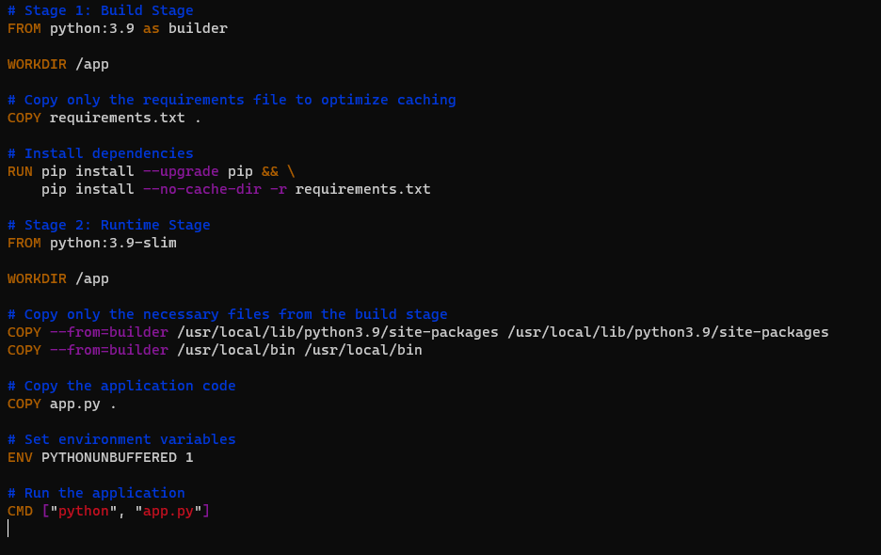

**In this example:**

* **Stage 1 (Build Stage):** Uses the **python:3.9** base image and installs dependencies specified in **requirements.txt**. This stage is used for building the application and creating the necessary dependencies.
* **Stage 2 (Runtime Stage):** Uses a smaller base image **python:3.9-slim** to reduce the overall size of the final image. Copies only the required files (dependencies and binaries) from the build stage into the final image. The application code is also copied, and the runtime CMD is set to run the application.

**Now build the docker image by using command: “docker build -t my_python_app .”**

**Example of Normal Dockerfile vs Multi-Stage Dockerfile:**

* **Normal Dockerfile:**

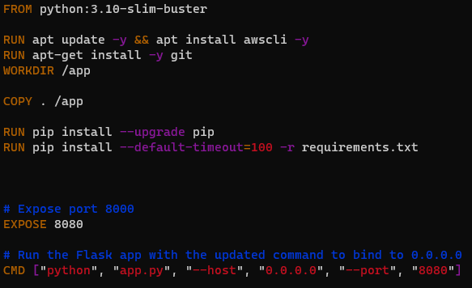

* **Multi-Stage Dockerfile by modify the normal Dockerfile:**

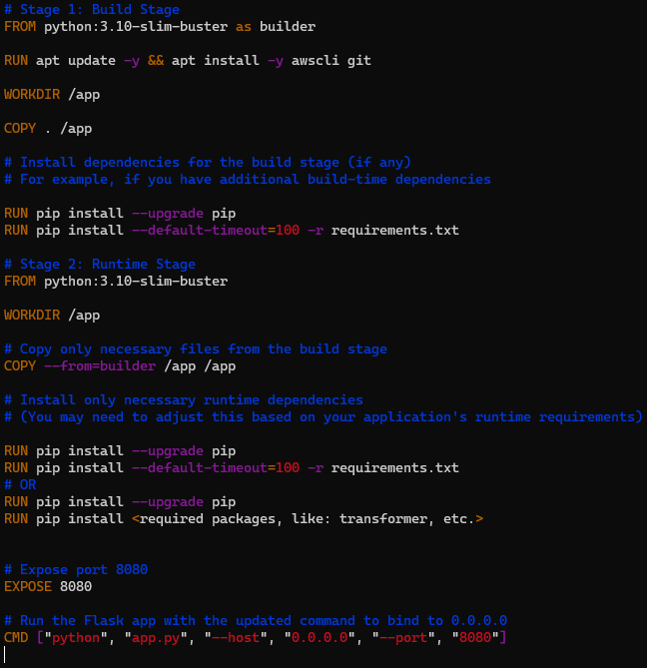

**In this modified Dockerfile:**

* + **Stage 1 (Build Stage):**
    - Uses **python:3.10-slim-buster** as the base image.
    - Installs build-time dependencies (**awscli** and **git**) needed during the build process.
    - Copies the entire application code into the build stage.
    - Installs any additional dependencies required for the build process.
    - Performs any necessary build steps.
  + **Stage 2 (Runtime Stage):**
    - Uses the same **python:3.10-slim-buster** as the base image.
    - Copies only the necessary files from the build stage, discarding unnecessary build artifacts.
    - Installs only the necessary runtime dependencies for the application.

**What is Distroless images in Docker:**

Distroless images in Docker are minimalistic container images designed for specific purposes, **with the primary goal of reducing the attack surface and minimizing the image size**. Unlike traditional base images that include a full operating system with various tools and utilities, Distroless images are stripped down to include only the essential components needed to run a specific type of application. [**Distroless Images GitHub Link**](https://github.com/GoogleContainerTools/distroless)

**Key characteristics of Distroless images:**

* **No Operating System:** Distroless images are built without a traditional operating system. They don't include package managers, shells, or other unnecessary components found in general-purpose base images.
* **Minimal Attack Surface:** By excluding unnecessary components, Distroless images have a significantly reduced attack surface. This makes them more secure because there are fewer potential vulnerabilities that could be exploited.
* **Application-Specific:** Distroless images are tailored for specific types of applications, such as Python, Java, or Node.js applications. Each Distroless variant is optimized to include only the runtime and dependencies required for that specific type of application.
* **Immutable and Read-Only:** Distroless images follow the principle of **immutability**. Once built, the images are read-only, and no changes are allowed during runtime. This aligns with best practices for container security.
* **Language Runtime Only:** Distroless images typically include only the language runtime and necessary libraries for executing the specific type of application. They exclude unnecessary tools, shells, and system-level components.
* **Reduced Image Size:** Distroless images are designed to be lightweight, resulting in smaller image sizes compared to base images that include a full operating system. This is particularly beneficial for faster image pull times and reduced storage requirements.
* **Simplified Dependency Management:** Distroless images simplify dependency management by providing a curated set of dependencies tailored for the application runtime. This reduces the complexity of dealing with unnecessary dependencies and libraries.

**Here's an example of using a Distroless image for a simple Python application:**

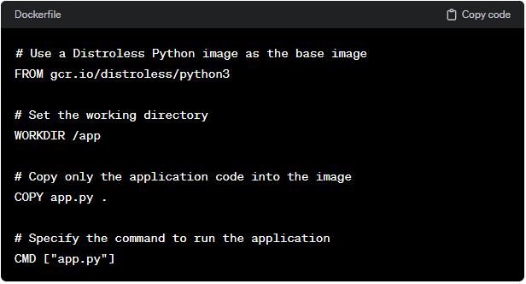

In this example, the **gcr.io/distroless/python3** image is a Distroless variant optimized for Python applications. It includes only the Python runtime and necessary libraries, providing a minimal environment for running Python applications.

Distroless images are often used in environments where security and minimalism are top priorities. They are suitable for deploying containerized applications when a full operating system is not required, and only the runtime environment and dependencies are necessary. Google maintains a set of Distroless images for various programming languages, making it easy for developers to adopt this minimalistic approach in their Docker workflows.

**Docker Bind Mount:**

A Docker bind mount is a method for **creating a persistent link or connection between a directory on the host machine and a directory within a container**. This allows the container to access and modify files or directories on the host, and vice versa. Bind mounts are useful for scenarios where you need to share data or configuration files between the host and the container, or when you want changes made in one location to be reflected in the other.

**Definition:** A Docker bind mount, often referred to simply as a "Docker mount," links a directory on the host machine to a directory in a container. It allows for sharing data between the host and the container and vice versa.

**The syntax for creating a bind mount is as follows:**

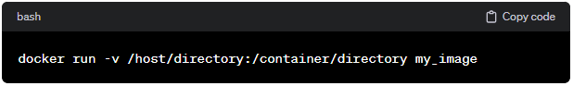

* **/host/directory:** This is the path to the directory on the host machine.
* **/container/directory:** This is the path to the directory inside the container.
* **my_image:** This is the name of the Docker image.

**Here are some key points about Docker bind mounts:**

* **Bi-Directional Data Sharing: Changes made in the host directory are reflected in the container**, **and changes made in the container directory are reflected on the host**. It establishes a bidirectional link.
* **Persistence:** Data in the bind-mounted directory persists even if the container stops or is removed. This makes bind mounts suitable for persisting data and configuration files.
* **Dynamic Updates:** Bind mounts allow for dynamic updates. For example, if a file is added, modified, or deleted on the host, the changes are immediately visible in the container and vice versa.
* **Use Cases:** Bind mounts are commonly used for scenarios such as sharing configuration files, providing access to application logs, or allowing the container to read/write data to a shared location on the host.
* **Flexible Syntax:** The syntax allows you to specify the mount point in the container as well as the location on the host. This flexibility allows you to choose the directory structure within the container.

**Here's an example of using a bind mount in a Docker run command:**

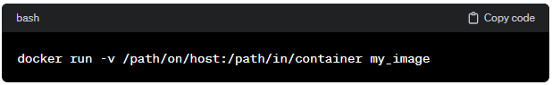

In this example, the directory **“/path/on/host”** on the host machine is mounted into the container at **“/path/in/container”**.

It's important to note that bind mounts provide direct access to the host filesystem, and care should be taken to ensure proper permissions and security practices to prevent unauthorized access or modification of sensitive data.

**Docker Volume:**

A Docker volume is a mechanism for persistently storing data generated by and used by Docker containers. **Volumes provide a way to share and manage data between containers, and they are independent of the container's lifecycle**. Unlike bind mounts, which link a directory on the host machine to a directory in a container, volumes are managed by Docker and can be used to store data outside the container filesystem.

**Definition:** A Docker volume is a persistent data storage mechanism managed by Docker that allows data to be stored outside the container's filesystem.

**Key characteristics of Docker volumes:**

* **Persistence:** Volumes are persistent storage entities that exist independently of containers. They persist even if the container is stopped or removed, making them suitable for storing long-term data such as databases, application configuration, and user uploads.
* **Isolation:** Volumes provide isolation between containers, allowing multiple containers to share and access the same data without interfering with each other.
* **Docker-Managed:** Docker volumes are created and managed by Docker. Users can create named volumes or allow Docker to create anonymous volumes. Docker handles the underlying details of volume creation, mounting, and management.
* **Ephemeral Container:** Volumes can be used with ephemeral containers for specific tasks such as data migrations, backups, or restores. Ephemeral containers are short-lived and perform a specific function, and they can be mounted with volumes to access or manipulate data.
* **Efficiency Data Sharing:** Volumes provide an efficient way to share and persistently store data across containers. They are faster and more efficient than copying data between containers or using bind mounts.
* **Container Agnostic:** Volumes are not tied to a specific container, allowing multiple containers to share the same volume. This makes them versatile for scenarios where data needs to be shared or reused across different services.

**Here are some basic examples of using Docker volumes:**

1. **Create a Named Volume:**

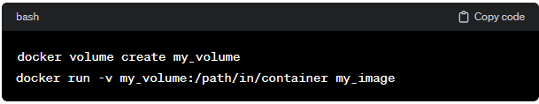

1. **Use an Anonymous Volume:**

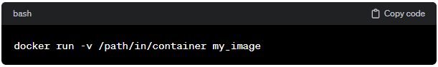

In this case, Docker creates an anonymous volume, and the path in the container is automatically generated.

1. **Mount a Host Directory as a Volume:**

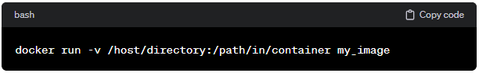

This binds the **/host/directory** on the host to **/path/in/container** in the container.

**Difference Between “Docker Volume” & “Docker Mount”:**

* **Persistence:** 
  + **Volume:** Volumes are persistent storage entities managed by Docker and persist independently of container lifecycles.
  + **Mount:** Bind mounts provide access to data on the host and are not managed by Docker. They persist as long as the underlying host data persists.
* **Management:** 
  + **Volume:** Docker volumes are created, named, and managed by Docker using the **docker volume** commands.
  + **Mount:** Bind mounts are specified directly in the **docker run** command using the **-v** flag.
* **Isolation:** 
  + **Volume:** Volumes provide isolation between containers, allowing multiple containers to share the same volume without interfering with each other.
  + **Mount:** Changes made in a bind mount on the host are immediately reflected in the container, and vice versa.
* **Use Cases:** 
  + **Volume:** Suitable for scenarios where persistent and managed storage is needed, such as for databases or configuration data.
  + **Mount:** Useful for development environments, accessing host files, or scenarios where direct access to host data is required.

**Docker Networking:**

Docker provides a networking subsystem that **allows containers to communicate with each other and with the outside world**. Docker networking enables containers to have their own network stack, IP address, and connectivity, making it possible for multiple containers to interact in various ways.

**Here are some key aspects of Docker networking:**

1. **Bridge Network:**

By default, when you install Docker, it creates a bridge network named **bridge** Containers attached to this network can communicate with each other using container names as hostnames. Docker automatically assigns IP addresses to containers in this network.

* **Example:**

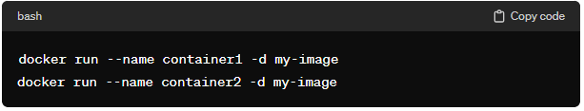

Containers can communicate using their names:

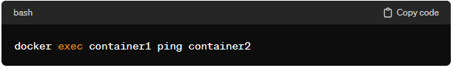

1. **Host Network:**

Containers can also use the host network, where they share the network namespace with the Docker host. This means they have the same network interface and IP address as the host, effectively bypassing Docker's network isolation.

* **Example:**

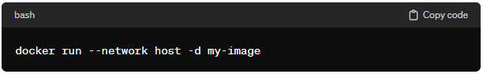

1. **Custom Bridge Network:**

You can create custom bridge networks to allow containers keeping them isolated from other networks.

* **Example:**

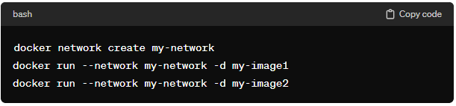

1. **Overlay Network:**

Docker supports overlay networks, which are used in **Docker Swarm** mode for multi-host communication. Overlay networks allow containers on different hosts to communicate as if they were on the same network.

1. **Macvlan Network:**

This type of network allows containers to have MAC addresses associated with the physical network interface on the host. It's useful when you want containers to appear as physical devices on the network.

1. **Container-to-Container Communication:**

Docker provides features like container linking and service discovery to facilitate communication between containers. With container linking, you can establish a secure communication channel between linked containers.

1. **External Connectivity:**

Docker containers can be connected to the external network, allowing them to access the internet or other external resources. You can use the **-p** option to publish ports and make them accessible from the host or external network.

These networking features make Docker versatile and suitable for a variety of use cases, from simple standalone applications to complex microservices architectures. The choice of networking options depends on the specific requirements of your application and the desired level of isolation between containers.

**Why networking is need in Docker.**

Networking is a crucial aspect of Docker for several reasons, contributing to the platform's flexibility, scalability, and ease of use.

**Here are some key reasons why networking is essential in Docker:**

1. **Isolation and Security:**

* **Container Isolation:** Docker containers are designed to be isolated from each other and from the host system. Networking plays a key role in maintaining this isolation, ensuring that containers don't interfere with each other.
* **Network Segmentation:** Docker allows you to create custom bridge networks, which can be used to segment and isolate groups of containers. This helps in controlling which containers can communicate with each other.

1. **Microservices Architecture:** 
   * **Service Communication:** In microservices architectures, applications are often divided into small, independent services. Networking in Docker allows these services to communicate with each other efficiently, either within a single host or across a cluster of hosts using overlay networks in Docker Swarm or other orchestration tools.
2. **Port Mapping and External Connectivity:** 
   * **Port Mapping:** Docker enables you to map ports from the host to the container, allowing external access to specific services within the container. This is crucial for exposing and accessing services running inside containers.
   * **External Connectivity:** Containers can connect to external networks and services, such as databases, APIs, or the internet, making them versatile for a wide range of applications.
3. **Scalability:** 
   * **Load Balancing:** In scenarios where, multiple instances of a service are deployed, Docker networking allows load balancing across those instances. This ensures even distribution of traffic and optimal resource utilization.
   * **Container Orchestration:** Docker networking is a fundamental component of container orchestration tools like Kubernetes and Docker Swarm, enabling the management and scaling of containerized applications across multiple hosts.
4. **Flexibility and Customization:** 
   * **Custom Networks:** Docker allows you to create custom bridge networks with specific configurations, such as subnet ranges, gateway addresses, and DNS settings. This customization provides flexibility in tailoring the network environment to suit the needs of the application.
5. **Service Discovery:** 
   * **DNS Resolution:** Docker automatically provides DNS resolution between containers on the same network. Containers can use each other's names as hostnames, simplifying service discovery within a Docker network.
6. **Multi-Container Applications:**
   * **Inter-Container Communication:** Many applications consist of multiple containers that need to communicate with each other. Docker networking facilitates this communication, allowing containers to interact seamlessly.

In summary, networking in Docker is crucial for maintaining isolation, enabling communication between containers, facilitating external connectivity, supporting microservices architectures, and ensuring scalability and flexibility. These features collectively contribute to Docker's ability to run and manage a wide variety of applications across diverse deployment scenarios.

**Explain Bridge Networking, Host Networking, Overlay Networking.**

* **Bridge Network:**
* **Overview:** 
  + **Default Networking:** When you install Docker, it creates a default bridge network named **“bridge”**.
  + **Isolation:** Containers connected to the same bridge network can communicate with each other, and they are isolated from containers on other bridge networks.
  + **Dynamic IP Assignment:** Docker automatically assigns IP addresses to containers in the bridge network.
* **Uses:**
  + **Default Behavior:** If you don't specify a network while running a container, it is connected to the default bridge network.
  + **Custom Bridge Network:** You can create custom bridge networks for better segmentation and isolation.
* **Example:**

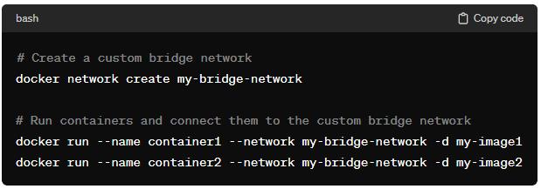

* **Host Network:**
  + **Overview:** 
    - **Shared Network Namespaces:** Containers using host networking share the network namespace with the Docker host.
    - **Same IP Address:** Containers directly use the host's network stack, having the same IP address as the host.
    - **Performance:** Containers on host networking usually have better performance as they avoid the additional network abstraction layer.
  + **Uses:**
* **Single-Host Scenarios:** Host networking is often used when maximum performance and minimal isolation are required within a single host.
  + **Example:**

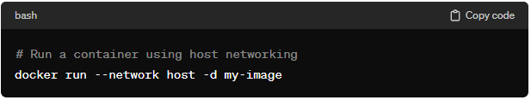

* **Overlay Network:**
  + **Overview:** 
    - **Multi-Host Communication:** Overlay networks are used in Docker Swarm mode or other orchestrators to facilitate communication between containers on different hosts.
    - **Encapsulation:** Overlay networking encapsulates the container traffic in an overlay protocol, allowing communication between containers on different hosts as if they were on the same network.
    - **Build-in Encryption:** Overlay networks often come with built-in encryption to secure communication between nodes.
  + **Uses:**
    - **Docker Swarm:** Overlay networking is commonly used in Docker Swarm mode for multi-host deployments.
  + **Example:**

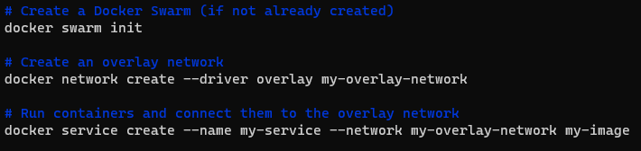

* + **Notes:**
* Docker Swarm is Docker's native clustering and orchestration solution.
* Overlay networking is particularly useful in scenarios where a microservices architecture spans multiple hosts, and containers need to communicate across host boundaries.

These networking options in Docker provide flexibility for different use cases, from single-host development environments to complex multi-host production deployments with orchestration. The choice of networking mode depends on the specific requirements of your application and the desired level of isolation and performance.

**What is Virtual Ethernet (veth) in docker networking.**

In Docker networking, a Virtual Ethernet (veth) pair refers to a set of virtual network interfaces that come in pairs, acting as the two ends of a communication link. One end of the veth pair is typically inside the container, while the other end is associated with the bridge network on the host. These virtual Ethernet pairs are used to facilitate communication between the container and the host's networking infrastructure, allowing the container to send and receive network traffic.

In simple terms, a veth pair creates a virtual network interface within the container and pairs it with an interface on the host, **enabling the container to connect to the broader network through the host's network stack**. This mechanism is part of the underlying technology Docker uses to provide networking isolation and connectivity for containers.

**What is “docker0” (docker-zero) in docker network.**

In Docker networking, "**docker0**" refers to the **default bridge network** created by Docker when it is installed. It is a virtual bridge network interface that serves as the default bridge for Docker containers on a host. The "docker0" bridge allows communication between containers on the same host and provides a default network for containers that do not explicitly specify a custom network.

**What is “eth0” in docker network.**

In Docker networking, "**eth0**" typically refers to the default network interface inside a Docker container. When a container is created, it gets its own isolated network namespace, and "eth0" is the default name assigned to the first (and often only) network interface within that namespace.

This interface, "**eth0**," is responsible for handling network communication within the container. It connects the container's network namespace to the Docker bridge network (like "docker0" in the host namespace) or any custom network the container is attached to. The IP address assigned to "eth0" is specific to the container and is usually dynamically allocated by Docker's networking subsystem.

In summary, "eth0" is the default network interface inside a Docker container, responsible for managing the container's network connectivity within the isolated network namespace.

**Docker Networking:**

**HOST**

**DOCKER**

**Default Bridge Network**

**Custom Bridge Network**

**Container-1**

**(login-container)**

**Container-2**

**(logout-container)**

**Container-3**

**(finance-container)**

**Docker Compose:**

Docker Compose is a tool that helps you define and run multi-container Docker applications. It allows you to manage the configuration of multiple Docker containers using a simple YAML file, making it easier to set up, manage, and scale complex applications.

**Why Docker Compose:**

When you have an application that consists of multiple services or containers, coordinating their setup and interaction can become complex. Docker Compose simplifies this process by allowing you to define all the services, networks, and volumes in a single configuration file. It helps in orchestrating the deployment of interconnected containers, making it more manageable and repeatable.

**Importance of Docker Compose:**

* **Easy Configuration:** Docker Compose uses a declarative YAML file to describe your application's services, making it easy to understand and modify.
* **Consistent Development Environments:** Docker Compose ensures that your development, testing, and production environments have consistent configurations, reducing the chance of "it works on my machine" issues.
* **Single Command Deployment:** With a single command (**docker-compose up**) you can start all the services defined in your **docker-compose.yml** file.
* **Scaling Services:** Docker Compose allows you to scale services easily. For example, if your application has a web service, you can run multiple instances of it with a simple command.
* **Isolation and Interconnection:** Containers defined in a Docker Compose file can communicate with each other through defined networks, and they can share data through specified volumes.

**Example:**

Imagine you're building a web application with a front-end, a back-end database, and a caching service. Using Docker Compose, you can define these services in a file (**docker-compose.yml**) like this:

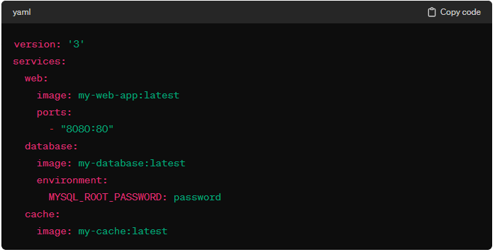

**Here,**

* **web** is your web application.
* **database** is your database services.
* **cache** is your cashing services.

With a simple command **docker-compose up**, Docker Compose would start all these services, and they would be able to communicate with each other. This helps simplify the deployment of your multi-container application, making it more organized and easier to manage.

In summary, Docker Compose is like a conductor for your orchestra of containers, helping you manage, deploy, and scale multi-container applications effortlessly. It's especially useful for development, testing, and small to medium-sized production setups.

**Docker Commands:**

**Here's a list of some common Docker commands along with their uses:**

1. **Image Commands:**

* **docker images**
  + **Use:** List all locally available Docker images.
  + **Example:** docker images
* **docker pull <image_name>**
  + **Use:** Download a Docker image from a registry.
  + **Example:** docker pull ubuntu:latest
* **docker build -t <image_name> <path>**
  + **Use:** Build Docker image from a registry.
  + **Example:** docker build -t dibyendubiswas1998/doc_tag_image .
* **docker rmi <image_id>**
  + **Use:** Remove Docker Images.
  + **Example:** docker rmi <image_id>

1. **Container Commands:**

* **docker ps**
  + **Use:** List running containers.
  + **Example:** docker ps
* **docker ps -a**
  + **Use:** List of all containers, including stopped one.
  + **Example:** docker ps -a
* **docker run [options] <image_name> <command>**
  + **Use:** Create and start a new container from an image.
  + **Example:** docker run ubuntu:latest --name my_image
* **docker start <container_id>**
  + **Use:** Start a stopped container.
  + **Example:** docker start <container_id>
* **docker stop <container_id>**
  + **Use:** Stop a running container.
  + **Example:** docker stop <container_id>
* **docker rm <container_id>**
  + **Use:** Removed a stopped container.
  + **Example:** docker stop <container_id>
* **docker exec -it <container_id> <command>**
  + **Use:** Execute a command inside a running container.
  + **Example:** docker exec -it <container_id> </bin/bash or bash>
* **docker run -d <image_name>**
  + **Use:** Runs a container in the background, and you get your terminal prompt back.
  + **Example:** docker run -d <image_name>
* **docker run -p <external_port>:<container_port> <image_name>** 
  + **Use:** Maps a port on the host to a port on the container, allowing access to the service inside the container from the host machine.
  + **Example:** docker run -p 8080:80 ubuntu:latest
* **docker run -d -p <external_port>:<container_port> <image_name>**
  + **Use:** Maps a port on the host to a port on the container in detach mode, allowing access to the service inside the container from the host machine.
  + **Example:** docker run -d -p 8080:80 ubuntu:latest

1. **Volume Commands:**

* **docker volume ls**
  + **Use:** List of Docker Volumes.
  + **Example:** docker volume ls
* **docker volume create <volume_name>**
  + **Use:** Create a Docker Volume
  + **Example:** docker volume create <volume_name>
* **docker volume rm <volume_name>**
  + **Use:** Remove a docker volume.
  + **Example:** docker volume rm <volume_name>

1. **Network Commands:**

* **docker network ls**
  + **Use:** List of Docker Networks.
  + **Example:** docker network ls
* **docker network create <network_name>**
  + **Use:** Create new network or custom bridge network.
  + **Example:** docker network create <network_name>
* **docker run -d -p 8080:80 --name <image_name> --network <network_name> <image_name>**
  + **Use:** Runs a container by using network mapping (custom bridge network).
  + **Example:** docker run -d -p 8080:80 --name <image_name> --network <network_name> <image_name>
* **docker network rm <network_name>**
  + **Use:** Remove a docker network.
  + **Example:** docker network rm <network_name>
* **docker network inspect <network_name>**
  + **Use:** Display detailed information about a Docker network.
  + **Example:** docker network inspect <network_name>

These commands cover a range of Docker operations, from managing images and containers to volumes and networks. Docker provides many more commands and options, so it's recommended to refer to the official Docker documentation for in-depth information and advanced use cases.